

WordClock 1–4
Word Clock System
Operator’s Manual

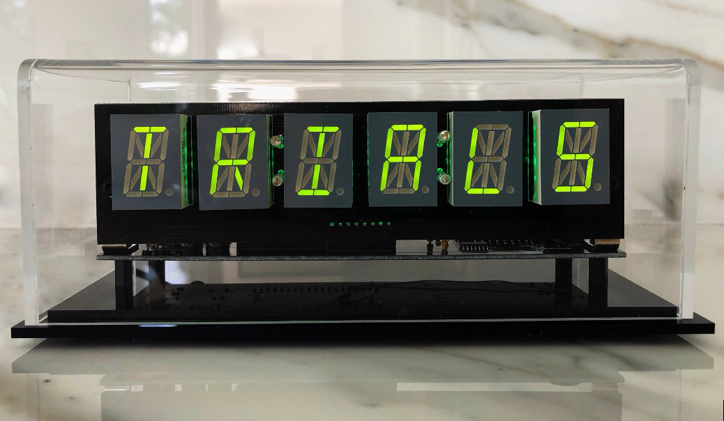 | 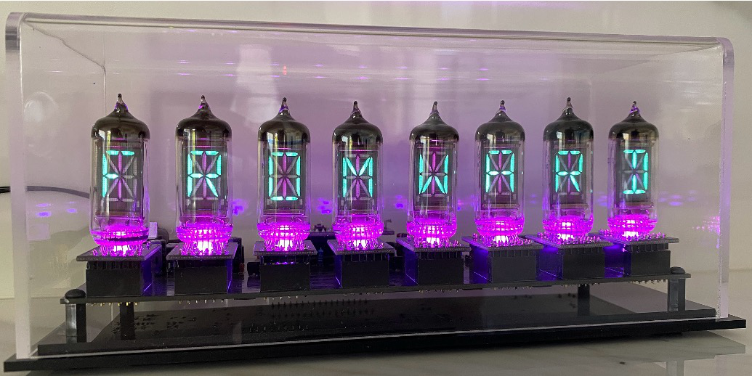
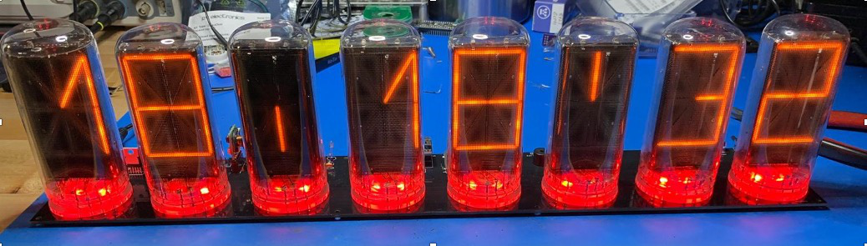 | 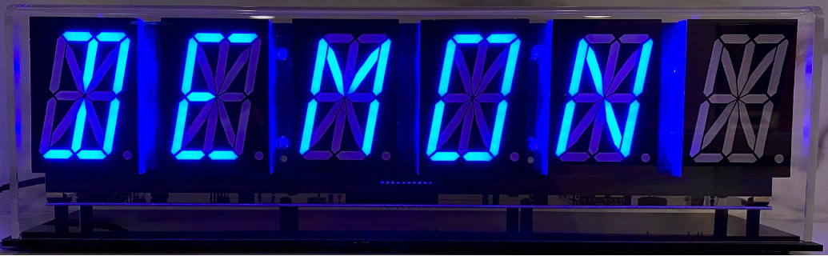
October 2026
This manual describes the installation, configuration, and day-to-day operation of the WordClock 1, 2, 3, and 4 family.
Revision/Update Information: | Updated guide (Revision 3)
Clock Firmware: | V3.7
Designed by Mitchell Feig — Angry Electrons
Distributed by StocksClocks LLC
Copyright © 2026 Mitchell Feig

Table of Contents

Quick Start QS-1
1. Overview 1-1
2. Models 2-1
3. Display 3-1
4. Buttons 4-1
5. Power-On Functions 5-1
6. AP Configuration Mode 6-1
7. Live Settings Web Interface 7-1
8. Rule Scheduler 8-1
9. Backlight (LED) Effects 9-1
10. Word Change Effect 10-1
11. Date, Weather, and Announcements 11-1
12. Word Libraries 12-1
13. Sensors 13-1
14. Time Synchronization 14-1
15. Firmware Updates 15-1
16. Factory Reset 16-1
17. Display Messages 17-1
18. Troubleshooting 18-1

Quick Start

Follow these steps to set up the WordClock for the first time. A full explanation of every option is in the numbered sections that follow.

1. Power on
Connect the clock to its 9–12V DC power adapter (1A or 2A minimum, depending on the model — see Section 2). Use a 5.5 × 2.1 mm center-positive barrel plug. On a brand-new clock, the display shows "AP" — this is the Access Point (AP) configuration mode. (On a previously-used clock that already has WiFi credentials, skip to step 4. To reconfigure WiFi later, hold SW2 for 5 seconds during normal operation and then release it to enter AP mode.)

2. Connect to the clock's WiFi
From a phone or computer, open the WiFi settings and connect to the network named after the clock's model — for example "WordClock-1-6" for a 6-digit LED clock or "WordClock-3-8" for an 8-digit VFD. No password is required.

3. Configure in a browser
Open a web browser and go to 192.168.4.1. The setup form loads. At a minimum, navigate through the pages and:
- On the Setup page, select the home WiFi network from the SSID list and enter the password. On a clock with no saved network the list starts on "-- select your network --"; select the home network before pressing Start.
- Confirm the UTC offset for the local region (the default, 5:00 with direction "-", is US Eastern).
- On the Libraries page, confirm Library 1 is set (the default English library is required).
Then press Start on the home page. The clock saves every setting, reboots, and begins normal operation. (Save Settings, at the bottom of each page, stores the settings but leaves the clock in AP mode; only Start switches it to normal operation.)

4. Wait for time to appear
During boot the display lights each segment position in turn and scrolls the model and firmware version. It then shows "Wi-Fi" while connecting to the network and "NTP" while fetching the time from the internet, scrolls the clock's IP address (on clocks that support it, also its .local name — see Section 7) and its WiFi signal strength, and shows each enabled library name with an "Index" or "No Idx" status. Time and rotating words appear a few seconds later.
If the Wi-Fi connection and NTP sync have not both completed within about two minutes, the clock reboots and tries again. After three failed boots in a row (for example a wrong Wi-Fi password or a renamed network), the next boot starts AP mode instead, so the Wi-Fi settings can be corrected at 192.168.4.1. Because each attempt allows about two minutes, this takes several minutes. This forced AP mode lasts for that one boot only: correct the settings and press Start to save them and reboot into normal operation. Pressing Save without Start stores the settings but does not keep the clock in AP mode; the next power-cycle tries the saved network again. If the network was only temporarily down (router rebooting, internet outage), power-cycling the clock returns it to normal operation.

5. Daily use
To do this | Do this
Show the time, or wake a display that a rule has dimmed or blanked | Click SW1 once
See the clock's IP address | Double-click SW1 — the address scrolls across the display
Cycle the expletive level (Off/Mild/Medium/Strong) | Click SW2 once
Adjust most settings live | Browse to http://<ip-address>/ from any device on the same WiFi
Send a custom scrolling message to the display | Use the Display Message field on the live web page
Install new firmware over WiFi | Hold SW1 for 10 seconds and release, or press Update Firmware on the live page's System page

6. Recommended next steps
- Visit the live web interface to explore backlight effects, colon patterns, word transitions, and other display options.
- Add rules in the live page's Rule Editor to dim or turn off the display during sleeping hours (see Section 8).
- If a BME280 weather sensor is installed, enable the inside temperature, pressure, or humidity readings on the Information page. To enable outside weather, register for a free Visual Crossing API key at visualcrossing.com and enter the key, postal code, and country code on the setup form's Information page.

1. Overview

WordClock uses alphanumeric LED displays, VFD displays, or B7971 Nixie tubes to present the time, date, and rotating word libraries in a distinctive text-based format. Models are available with 6, 8, or 16 characters depending on display type.
The standard software includes an English word library, optional expletive files with selectable rudeness levels, announcements by month and day, and support for additional user-supplied libraries and languages. Words and phrases are stored on a removable SD card as plain-text files that can be edited with any text editor.
WordClock synchronizes its time from an internet NTP server over WiFi. Additional features include a Rule Scheduler that changes display settings by time of day and day of the week, RGB backlight effects, inside and outside weather display, a live browser-based settings page that can be added to a phone's home screen, custom scrolling messages, and over-the-air (OTA) firmware updates, including optional weekly automatic updates.
All settings are stored in non-volatile memory (NVS) and survive power cycles and firmware updates. Configuration is performed through a WiFi access point (AP) setup page or a live web interface accessible from any device on the same network.
Note: Some included libraries — particularly the British slang collections and BadW libraries — contain language that some users may consider offensive. Whilst that is somewhat the point, if young children or sensitive guests are present, the expletive level can be set to Off with SW2 or on the live web page.

2. Models

WordClock is sold in several display variants. The hardware variant is set at the factory and identified by a code stored in the clock's flash memory; it cannot be changed by the user. The default Access Point name and mDNS hostname both include the model identifier.
Power supply: 9–12V DC, center positive, 5.5 × 2.1 mm barrel plug. The 6-digit LED models are typically supplied with a 1A adapter; 8- and 16-digit LED, VFD, and Nixie models are supplied with 2A versions. Always use a quality regulated supply.
Model | Digits | Display Type | Notes
WordClock-1-6 | 6 | LED (alphanumeric) | 0.8" digits, single or dual LED ring backlight
WordClock-1-8 | 8 | LED (alphanumeric) | 0.8" digits
WordClock-1-16 | 16 | LED (alphanumeric) | 0.8" digits, dual I²C bus
WordClock-2-6 | 6 | LED (alphanumeric) | 2.3" digits
WordClock-2-8 | 8 | LED (alphanumeric) | 2.3" digits
WordClock-2-16 | 16 | LED (alphanumeric) | 2.3" digits, dual I²C bus
WordClock-3-6 | 6 | VFD (IV4 / IV17) | Vacuum-fluorescent tubes
WordClock-3-8 | 8 | VFD (IV4 / IV17) | Vacuum-fluorescent tubes
WordClock-3-16 | 16 | VFD (IV4 / IV17) | Vacuum-fluorescent tubes, dual I²C bus
WordClock-4-6 | 6 | Nixie (B7971) | Alphanumeric Nixie tubes, HV5530 driver
WordClock-4-8 | 8 | Nixie (B7971) | Alphanumeric Nixie tubes, HV5530 driver

If the display shows "BAD" at power-on and never starts, the model code stored in flash is missing or invalid. Contact the distributor.

3. Display

Depending on the model, the clock has 6, 8, or 16 alphanumeric character positions. Each position is a 14- or 16-segment alphanumeric element capable of rendering ASCII letters, digits, and a number of special characters. RGB backlight LEDs sit behind each character and can run a variety of patterns (see Section 9).
Status indicator: while the WiFi or NTP connection is lost, the backlight LEDs behind the leftmost character turn off briefly every 2 seconds, and stop once the connection returns. Because the indicator uses the backlight, it is not visible when the backlight is off.
On models with colon segments between digit pairs, Colon Display selects one of nine patterns: Off, All On, Bottom Flash, All Flash, Cross Flash (the default), Railroad, Left -> Right, AM/PM Bottom-Left/Top-Right Off, and AM/PM Bottom-Left/Top-Right On (see Section 6, Display Page).

4. Buttons

The clock has two buttons: SW1 (left) and SW2 (right). Their behavior differs between normal operation and power-on (Section 5). The hold actions below take effect when the button is released.

SW1 — During Normal Operation
Action | Function
Single click | Show the time for the Rules Timeout period (15 s, 1 min, or 5 min). If a rule has dimmed, blanked, or changed the display, the saved settings return for that period. See Rules Timeout below.
Double-click | Scroll the IP address, the .local name (on clocks that support it — see Section 7), and the WiFi signal strength across the display. Requires a WiFi connection and the Live Form setting to be On.
Hold 10 seconds, then release | Check for and install a firmware update — see Section 15
Hold 20 seconds or longer, then release | Install the beta firmware build, when one has been published

SW2 — During Normal Operation
Action | Function
Single click | Cycle the expletive level: Off → Mild → Medium → Strong → Off. The level name briefly appears on the display. The change is temporary; the Expletive Default setting applies again after a restart. If a rule is in effect, this click also turns Rules off (see Section 8).
Double-click | Restart into Access Point configuration mode, keeping the current settings
Triple-click | Show the light-sensor reading (0–15) for 30 seconds (calibration mode — see Section 13)
Hold 5 seconds, then release | Restart into Access Point configuration mode, keeping the current settings
Hold 20 seconds or longer, then release | Reinstall the current release from the firmware server, whatever version is installed (see Section 15)

Rules Timeout
A single click of SW1 forces the time display (Clock Mode Always On) for the Rules Timeout period set on the live page's Rule Editor page: 15 seconds (default), 1 minute, or 5 minutes. If a rule has dimmed, blanked, or otherwise changed the display, the saved settings return for that period. When the period expires, the rule applies again. The click does not turn Rules off.

5. Power-On Functions

Special functions are available by holding buttons while applying power. Apply power to the clock with the indicated buttons held; release once the clock acknowledges the action.
Buttons Held | Function
SW1 only | Rebuild word library indexes from the SD card. The display shows "Index"; release SW1. The clock then shows each library folder on the card in turn, about 2.5 seconds each. Press and hold SW1 while a library name is shown to rebuild only that library; otherwise every library is rebuilt. Progress is shown as a percentage, and the clock restarts when finished. See Section 12.
SW2 only | Burn-in mode. After the clock connects to the network, all segments stay on at full brightness until either button is pressed. Useful for exercising IV4 / IV17 VFD tubes on WordClock-3 models. Not available on Nixie models.
SW1 + SW2 | Factory reset. Clears all stored settings, including the Wi-Fi credentials, and starts Access Point mode. The saved rules and the hardware model code are preserved. See Section 16.

6. AP Configuration Mode

Entering AP Mode
- Power on a brand-new clock — it starts directly in AP mode, OR
- Hold SW2 for 5 seconds during normal operation and then release it (or double-click SW2), OR
- Press Switch to AP Mode on the System page of the live web interface, OR
- Perform a factory reset (Section 16), OR
- After three boots in a row that fail to connect to Wi-Fi and sync the time, the next boot starts AP mode for that one boot (see Quick Start, step 4). Press Start after correcting the settings; power-cycling instead retries the saved network.
In AP mode the display shows "AP" continuously. Entering AP mode keeps the current settings; they appear on the setup form ready for editing.

Connecting
1. Connect a phone or computer to the Wi-Fi network broadcast by the clock — by default "WordClock-" followed by the model, such as "WordClock-1-6" or "WordClock-3-8" (the name can be changed with Access Point Name). The AP is open (no password).
2. Open a web browser and go to 192.168.4.1.
3. Step through the pages of the setup form, then press Start on the home page. Start saves every setting and restarts the clock in normal operation. Save Settings, at the bottom of each page, stores the settings without leaving AP mode.
The setup form has four pages — Setup (network, time zone, and firmware URL), Libraries, Display, and Information. Use the page buttons on the home page to navigate. The Rule Editor is not part of the setup form; it is on the live web interface once the clock has joined the home network (Section 8).

Setup Page — Network
Setting | Description
Access Point Name | Name of the Wi-Fi network the clock broadcasts in AP mode; also the basis of its .local name and its home-screen icon label (default: WordClock- followed by the model)
SSID | Home Wi-Fi network, chosen from a scan list. The network shown is the one that is saved. On a clock with no saved network the list starts on "-- select your network --". A saved network that is not currently broadcasting is listed first, marked "(saved - not in range)". Networks whose names contain a comma are not listed; use SSID Override for them.
SSID Override | Type a network name here for a hidden network. When filled in, it takes priority over the SSID list; otherwise leave it blank.
Network Password | Wi-Fi password (up to 63 characters).
Live Form Password | Optional password for the live web interface. Leave blank for no password.
NTP Server | Primary internet time server (default: us.pool.ntp.org).
Alternate NTP Server | Second time server, used when the server in use has not answered for 30 minutes (default: time.google.com). Leave blank to disable.
NTP Polling Interval (minutes) | How often the clock re-synchronizes its time: 5, 15, 30, 60, 120, or 240 minutes (default: 240, every four hours). Boot and retry timing are not affected.
Live Form | Turns the live web interface on or off during normal operation (default: On). With it off, double-clicking SW1 does not show the IP address.

Note on NTP servers: many home routers offer a built-in NTP server. Pointing all home devices to the router (e.g. 192.168.1.1) avoids excessive load on public servers and complies with the NTP Pool Project terms of service, which ask that SNTP clients query no more than once every 30 minutes.

Setup Page — Time Zone and Daylight Saving Time
Setting | Options | Default
UTC Offset | HH:MM (supports half-hour and 45-minute regions) | 5:00
UTC Direction | -, + | -
DST Start Month | January–December | March
DST Start Week | 1–5 | 2
DST Start Day | Sunday–Saturday | Sunday
DST Start Hour | 0–23 | 2
DST Offset | 0, 1 (hours added during DST) | 1
DST Direction | -, + | +
ST Start Month | January–December | November
ST Start Week | 1–5 | 1
ST Start Day | Sunday–Saturday | Sunday
ST Start Hour | 0–23 | 2

The default time zone, Daylight Saving Time, and Standard Time settings are configured for US Eastern Time.

Setup Page — Time and OTA Update
Setting | Options | Default
Time Display | 12 Hour, 24 Hour, US English Verbose | 12 Hour
Firmware URL | Address of the firmware server | https://mitchsf.github.io/Firmware/

The Verbose time format spells the time in words — for example, "FIVE MINUTES AFTER 3" or "MIDNIGHT" — and works best on 8- and 16-digit displays. Time Display can also be changed on the live web interface.
The Firmware URL tells the clock where to fetch new firmware. The default points to the manufacturer's firmware server and should be left unchanged unless directed otherwise. If the field is cleared, the default is restored at the next restart. See Section 15.

Libraries Page
Up to five word libraries can be active at once. Library 1 is required (it provides the system message file used for all status text and is the default content source). Libraries 2–5 are optional and only used when the corresponding Use Library percentage is not Off. Each library is a folder on the SD card with files sharing the folder's base name. Libraries are chosen only on the setup form.
Setting | Options | Default
Library 1 | Any library folder on the SD card | English
Library 2 / 3 / 4 / 5 | Any library folder on the SD card, or none (-) | none
Use Library 2 / 3 / 4 / 5 | Off, 5%, 20% — how often words come from that library | 20% for Library 2; Off for Libraries 3–5
Time and Date Language | Always Library 1, Current Library | Always Library 1

"Always Library 1" forces the time and date to use the English (or Library 1) font and number labels even when a foreign-language library is currently displaying words. "Current Library" uses the active library's font for time and date.

Display Page
Setting | Options | Default
Brightness | 0–9 | 9
Clock Mode | Off, 15 Seconds, 30 Seconds, 60 Seconds, Always On | 30 Seconds
Colon Display | Nine patterns (see Section 3) | Cross Flash
Word Change Effect | Off, Slide Up, Slide Down, Slide Left, Slide Right, Energize, Random | Energize
Scroll All Words | Off, On | Off
Show Index Status at Start | Off, On | On
Show Announcements | Off, Every 30 Seconds, Every 60 Seconds | Every 60 Seconds
Announcement Override | Off, On | Off
Backlight Effect | 14 effects plus Cycle Effects (see Section 9) | Random Multi-Color Wave
Backlight Brightness | 0–9 | 9
Display LED Grouping | Separate, Matched (models with more than one LED per digit only) | Separate
Expletive Default | Off, Mild, Medium, Strong | Off
Expletive Mix | 5%, 20%, 50% | 5%

Clock Mode controls how often the time replaces the rotating word display: every 15, 30, or 60 seconds. "Always On" shows the time continuously, with no words, date, or weather. "Off" never shows the time. "Scroll All Words" makes every word scroll horizontally, even those that fit the display; otherwise short words are shown statically.
Show Index Status at Start shows "Index" or "No Idx" after each library name during startup. Announcement Override shows announcements even when Clock Mode is Always On. Expletive Default is the expletive level the clock starts with; SW2 changes the level temporarily. Expletive Mix sets how often expletives appear among the words.

Information Page
Setting | Options | Default
Date Display Start Second | 0–59 | 10
Date Display | MM/DD/YY, DD/MM/YY, YY/MM/DD, US English Verbose, Off | MM/DD/YY
Light Sensor | Off, On | Off
Min Display Brightness | 0–9 | 3
Min Backlight Brightness | 0–9 | 3
Motion Sensor | Off, 15 Seconds, 1 Minute, 5 Minutes, 10 Minutes, 15 Minutes, 30 Minutes, 1 Hour | Off

See Section 11 for when the date, weather, and announcements appear and Section 13 for sensor details.

Information Page — Weather
The weather settings always appear on the setup form. On the live web interface they appear only when a BME280 inside sensor is detected or a Visual Crossing key and postal code have been entered. The Weather Key, Postal Code, and Country Code are entered only on the setup form.
Setting | Options | Default
Start Second | 0–59 — second of the minute the weather appears | 35
Display Interval | 1 Minute, 5 Minutes, 15 Minutes, 1 Hour | 1 Minute
Temperature Units | Fahrenheit, Celsius, Kelvin | Fahrenheit
Pressure Units | Inches of Mercury, Millibars | Inches of Mercury
Inside: Temperature, Pressure, Humidity | Off, On (each) | Off
Inside: Offset | −15 to +15 (whole degrees) | 0
Weather Key | Visual Crossing API key (text) | blank
Postal Code or Lat/Lon | Location for weather lookups | blank
Country Code (2 Letter) | Two-character country code (e.g. US, GB, AU) | US
Outside: Temperature, Pressure, Humidity, Wind, Current Conditions | Off, On (each) | Off
Labels | Off, Short, Long | Off
Display Duration | 5 Seconds, 10 Seconds, 20 Seconds | 5 Seconds

7. Live Settings Web Interface

Once the clock is connected to a Wi-Fi network, the live settings page is reachable from any device on the same network. Most settings can be adjusted live without rebooting the clock — the change takes effect the moment the control is released.
Access: Browse to http://<clock-ip-address>/. To find the IP address, double-click SW1 — the address scrolls across the display. The page header shows the firmware version and the clock's IP address.
The live interface has four pages — Display, Information, Rule Editor, and System — reached from buttons on its home page. The home page also holds the Display Message field.

Saving Changes
Changes take effect immediately but are kept only until the next restart. Press Save Settings (at the bottom of any page) to store all changes made so far. Rule Editor changes — adding, editing, deleting, or moving a rule — are saved immediately and do not need Save Settings.
A settings change made while a rule is in effect turns Rules off — see Section 8.

Using a Name Instead of an IP Address (mDNS)
On clocks whose controller includes PSRAM memory, the clock can also be reached by name instead of by IP address. Browse to http://wordclock-1-6.local/ (or wordclock-3-8.local, wordclock-2-16.local, etc., matching the model) and the page should load. The hostname is derived from the Access Point Name set during configuration: lowercased, with spaces and underscores converted to hyphens and other punctuation removed. For example, an AP Name of "WordClock-1-6" becomes wordclock-1-6.local; "Kitchen Clock" becomes kitchen-clock.local. This makes it easy to give each clock in a multi-clock household a memorable address. When a clock supports a .local name, double-clicking SW1 scrolls the name after the IP address; clocks without PSRAM do not offer a .local name and are reached by IP address.
mDNS (also known as Bonjour or zero-configuration networking) does not work on every network. Some routers — particularly older models or routers with multicast filtering enabled — block the discovery messages mDNS depends on, in which case the .local address will not resolve. macOS, iOS, and Windows 10/11 generally work out of the box; some Android versions and Linux distributions require additional setup. If the .local address does not load, fall back to the IP address (double-click SW1 to display it).

Authentication
If a Live Form Password was set during AP configuration, the page prompts for it before any settings are shown. The username is left blank; enter the configured password. Clear the field in AP mode to disable authentication.

Display Page
- Display Brightness (0–9)
- Backlight Brightness (0–9)
- Backlight Effect (see Section 9)
- Display LED Grouping (Separate / Matched — models with more than one LED per digit only)
- Colon Display (nine patterns)
- Clock Mode (Off, 15 Seconds, 30 Seconds, 60 Seconds, Always On)
- Time Display (12 Hour, 24 Hour, US English Verbose)
- Word Change Effect (Off, four slide directions, Energize, Random)
- Show Announcements (Off, Every 30 Seconds, Every 60 Seconds) and Announcement Override
- Expletive Default and Expletive Mix

Information Page
- Date Display Start Second (0–59)
- Date Display — the numeric format chosen on the setup form, or US English Verbose (the numeric format itself is chosen on the setup form)
- Motion Sensor timeout
- Light Sensor, Min Display Brightness, Min Backlight Brightness
- Weather — Start Second, Display Interval, Temperature Units, Pressure Units, the inside readings and Offset (when a BME280 is detected), the outside readings (when a weather key and postal code are set), Labels, and Display Duration

Rule Editor Page
- Rules Enabled, Rules Timeout, the Rule input with Apply, Delete, and the Schedule list. See Section 8.

System Page
- Switch to AP Mode — restarts the clock into AP configuration mode, keeping the current settings (see Section 6).
- Reindex — rebuilds the word-library indexes on the SD card, showing progress on the display, then restarts the clock. Run it after any change to a word file (see Section 12).
- Add to Home Screen — installs the live page as an app icon on a phone or tablet. The icon is labelled with the clock's Access Point Name, so each clock gets its own icon. Where the browser cannot install directly, the button explains the steps (in Safari: Share, then Add to Home Screen).
- Update Firmware — checks the firmware server and installs a new version if one is available (see Section 15).
- Firmware URL — the firmware server address (see Section 6).
- Automatic Updates — weekly overnight installation of approved releases; On by default (see Section 15).
- Last Update Check — read-only: the result of the most recent update check, whether it was scheduled or manual, and when it ran.
- Memory — read-only memory and uptime figures, for diagnosis.

Custom Scrolling Message
The home page of the live web interface includes a Display Message text field (up to 64 characters). Type a message and press Send. The message scrolls across the display once at the next opportunity, then the clock returns to its normal display sequence. This is useful for greetings, reminders, or quick announcements visible to anyone in the room. Sending a message does not affect Rules.

8. Rule Scheduler

The Rule Scheduler changes display settings automatically by time of day and day of the week. It replaces the three Period Overrides and the Override Mode switch of earlier firmware. Up to 32 rules can be stored. Each rule combines a time window, an optional day filter, and one or more settings to apply during that window; settings a rule does not mention keep their saved values. The most common use is to dim or turn off the display during sleeping hours.
Rules are edited on the Rule Editor page of the live web interface; the setup form does not include the editor. Rules are stored separately from the other settings, so a factory reset does not erase them — delete unwanted rules in the Rule Editor.

Rule Editor Page
Control | Function
Rules Enabled | Switches the whole schedule off without deleting any rule. This switch is not saved: it returns to On after any restart.
Rules Timeout | How long a single click of SW1 shows the time and the saved settings: 15 Seconds (default), 1 Minute, or 5 Minutes. Stored with Save Settings.
Rule | Type a rule and press Apply. If the rule cannot be accepted, a message explains why. The tooltip beside the field lists every keyword and value this clock accepts.
Delete | Removes the selected rule. Tap a row in the Schedule first.
Schedule | All stored rules in priority order. Tap a row to load it into the Rule field for editing, then press Apply to replace that row. The up and down arrows move a rule, changing its priority. A warning mark flags a rule that overlaps a higher rule setting the same field.

Adding, editing, deleting, and moving rules are saved immediately; they do not need Save Settings. A loaded rule can also be deleted by adding the word del to it and pressing Apply.

Time Windows and Days
Every rule starts with a time window, written t= (or time=). Times have minute precision and the end is exclusive: t=22:00-7:00 runs from 10:00 PM through 6:59 AM and stops at 7:00. Windows may cross midnight. t=5-7, t=5:00-7:00, and t=0500-0700 are equivalent. A bare hour covers that whole hour (t=5 is 5:00 through 5:59), and t=all covers the whole day. A window whose start equals its end is rejected.
An optional day filter can follow the window: wd (Monday–Friday), we (Saturday and Sunday), a single day (sun, mon, tue, wed, thu, fri, sat; full names also work), or a range such as tue-thu (ranges may wrap, e.g. sat-mon). Several day terms combine, for example wd, sat. Without a day filter a rule applies every day. Commas or spaces separate the parts of a rule.

Rule Fields
Key (long form) | Setting | Values
br (brightness) | Display brightness | 0–9; 0 turns the display off (on Nixie models the high-voltage supply is also switched off)
lb (ledbright) | Backlight brightness | 0–9; 0 turns the backlight off
bl (backlight) | Backlight effect | 0–14, as numbered in Section 9 (14 = Cycle Effects)
ck (clockmode) | Clock Mode | 0 Off, 1 15 Seconds, 2 30 Seconds, 3 60 Seconds, 4 Always On
co (colon) | Colon Display | 0–8, in the order listed in Section 3 (0 = Off)
it, ip, ih | Inside temperature, pressure, humidity | Off / On (0 / 1)
ot, op, oh, ow | Outside temperature, pressure, humidity, wind | Off / On (0 / 1)
cc (conditions) | Current conditions | Off / On (0 / 1)
gr (ledgrouping) | Display LED Grouping | Separate / Matched (0 / 1) — only on models with more than one LED per digit

Values may be numbers or the option name typed without spaces, for example bl=twinkle or ck=alwayson. The long key names shown in parentheses (brightness=, backlight=, clockmode=, and so on) are also accepted, as are intemp, inpress, inhumid, outtemp, outpress, outhumid, and outwind for the weather keys.
Shortcuts: the bare word off sets br=0 and lb=0 (display and backlight off); the bare word on sets br and lb to the saved brightness values at the moment the rule is entered.

Examples
- t=22-7 off — display and backlight off from 10:00 PM through 6:59 AM.
- t=22:30-6:30 br=2 lb=1 ck=alwayson — dim overnight and show only the time.
- t=6-9 wd ot=on cc=on — on weekday mornings, add the outside temperature and current conditions to the weather display.
- t=all we bl=twinkle — Twinkle backlight all day on weekends.

Priority
Rules are evaluated every minute. When two or more matching rules set the same field, the rule higher in the Schedule wins; rules that set different fields combine. Use the up and down arrows to change a rule's priority.

Rules Enabled and Manual Changes
Rules Enabled switches the whole schedule off without deleting anything — useful when guests are visiting and the night-time dimming is not wanted. It is not saved; after any restart it returns to On and the schedule resumes.
A manual settings change while a rule is in effect turns Rules off. This applies to any setting changed on the live interface (including Rules Timeout and the Firmware URL) and to an SW2 click that changes the expletive level. The clock returns to its saved settings plus the change just made, and the page reloads with Rules Enabled showing Off. Turn Rules Enabled back on, or restart the clock, to resume the schedule. Editing rules, the Rules Enabled switch itself, sending a display message, the System page buttons, Automatic Updates, and an SW1 click do not turn Rules off.
SW1: a single click while a rule is in effect shows the time at the saved settings for the Rules Timeout period, after which the rule applies again (see Section 4).

9. Backlight (LED) Effects

A row of RGB LEDs sits behind the alphanumeric characters and provides a colored backlight. The number of LEDs depends on the model — some 6-digit clocks use 6 LEDs, others use 12 or 24; 8-digit clocks use 8, 16, or 32; the largest 16-digit clocks use up to 64. Effects scale automatically to the LED count.
# | Effect | Description
0 | Off | All LEDs dark
1 | USA Wave | Red, white, and blue cycling with sine-wave brightness modulation
2 | Blue-White Wave | Blue and white alternating wave
3 | Random Big Color Wave | Single random color (8-bit RGB) with sine-wave fade
4 | Random Every Color Wave | Single random full-spectrum color with sine-wave fade
5 | Random Multi-Color Wave | Different random color per LED with sine-wave fade (default)
6 | Twinkle | Random colors per LED, fading independently
7 | Larson Scanner | A light sweeps back and forth one digit at a time, about one second per sweep
8 | Red Wave | Red sine-wave fade
9 | Green Wave | Green sine-wave fade
10 | Blue Wave | Blue sine-wave fade
11 | Solid Red | Steady red, no animation
12 | Solid Green | Steady green, no animation
13 | Solid Blue | Steady blue, no animation
14 | Cycle Effects | Steps through effects 1–10, changing once a minute at the top of the minute

Backlight Brightness (0–9) is gamma-corrected so that small numbers correspond to dim, evenly-spaced steps and large numbers ramp up to maximum. Setting Brightness to 0 turns the LEDs off without changing the selected Effect.
Display LED Grouping (models with more than one LED behind each digit): Separate runs every LED independently; Matched gives all the LEDs under each digit one shared color. Rules can change it with the gr key.
Status indication: while the WiFi or NTP connection is lost, the LEDs behind the leftmost character turn off briefly every 2 seconds (see Section 3).

10. Word Change Effect

Word Change Effect animates how each new word from the active library replaces the previous word.
Effect | Description
Off | Instant replacement, no animation
Slide Up | New word slides in from below
Slide Down | New word slides in from above
Slide Left | New word slides in from the right
Slide Right | New word slides in from the left
Energize | Per-segment "energize" sweep — looks particularly good on VFD models (default)
Random | Picks one of the slide directions or Energize each time

The time and date always appear without a transition effect; the Time Change Effect setting of earlier firmware has been removed.

11. Date, Weather, and Announcements

Between words, the clock shows the date, weather, and announcements at set seconds of each minute, according to the Date Display, weather, and announcement settings.

Date
Displayed once a minute at the Date Display Start Second (default :10), as MM/DD/YY, DD/MM/YY, YY/MM/DD, or US English Verbose ("April 29, 2026"). Set Date Display to Off to skip the date. The date is not shown while Clock Mode is Always On or during an SW1 wake.

Weather
Weather appears as a single scrolling line at the weather Start Second (default :35), on the minutes that match the Display Interval (every minute, every 5 or 15 minutes, or once an hour). Display Duration (5, 10, or 20 seconds) sets how long the whole line takes to scroll across the display. Weather is shown only when Clock Mode is 15, 30, or 60 Seconds (it is not shown in Off or Always On).
Inside Weather: Read from a BME280 sensor on the I²C bus (auto-detected at addresses 0x76 and 0x77). Temperature, pressure, and humidity can each be turned on separately. The Inside Offset (whole degrees) is added to the inside temperature to correct sensor calibration.
Outside Weather: Fetched from Visual Crossing (https://visualcrossing.com — a free API key is required, together with a postal code or latitude/longitude and a country code). Temperature, pressure, humidity, wind, and current conditions can each be turned on separately. Wind shows as speed plus a 16-point compass direction (N, NNE, NE, ENE, E, ...). Current Conditions adds a short text description (e.g. "PARTLY CLOUDY").
Readings are shown as whole numbers. Fahrenheit shows wind in mph; Celsius and Kelvin show km/h. Pressure is shown in inches of mercury (inHg) or millibars (mb). When both inside and outside readings are shown, they are prefixed IN- and OUT- (INSIDE- and OUTSIDE- with Long labels). Labels can be turned Off, Short ("T-72F"), or Long ("TEMPERATURE 72F") to fit different display widths.

Weather Update Schedule
When outside weather is enabled, the clock fetches fresh data every 15 minutes. If the fetch fails, it retries after 5 minutes. Data older than 1 hour is treated as stale and the outside values are cleared until a successful fetch occurs. A weather setting changed on the live page takes effect within about a minute.

Announcements
Announcements are month-and-day messages from the Library 1 announcements file (see Section 12). On a day with a matching entry, the announcement replaces a word at :20 of each minute (Every 60 Seconds) or at :20 and :50 (Every 30 Seconds). The file is checked at startup and at midnight. While Clock Mode is Always On, announcements appear only when Announcement Override is On.

12. Word Libraries

Words, fonts, system messages, expletives, and announcements are all stored on a removable SD card. Each library is a folder at the root of the card, and the files inside share the same base name as the folder. Up to five libraries can be active at once; the SD card may contain up to 31 library folders to choose from.

Folder Structure
Each library folder contains a font file and a word file at minimum. Optional files add expletives, announcements, system messages, and a search index. For example, an English library would contain:
- /English/English.fnt — character bitmaps (required)
- /English/English.wds — word and phrase list (required)
- /English/English.idx — search index (optional; built by Reindex)
- /English/English.msg — system messages (required for Library 1 only)
- /English/English.xpl — expletive list with rudeness levels (optional)
- /English/English.ano — month/day announcements (optional, Library 1 only)
Library names may be up to 8 characters long and cannot contain spaces. Folders beginning with a dot ( . ) and the special folder EXTRAS are skipped.

Fonts (.fnt)
Plain-text files. Each line begins with 16 zeros and ones describing the segment states for one character, in the order: u t s r p n m k h g f e d c b a. ASCII characters from 32 to 255 may be defined within the limits of the display hardware. Comments after the 16-character segment definition are ignored. A library without its own font file uses the Library 1 font.
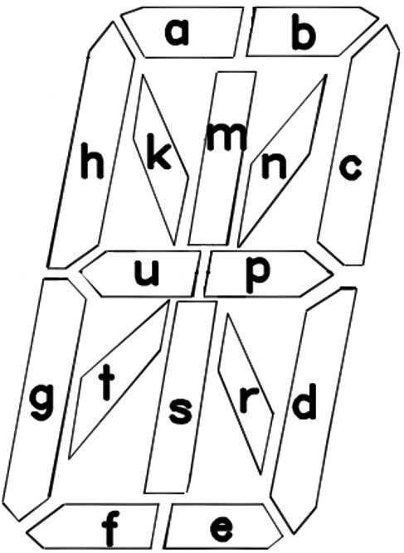
The diagram above shows the segment letter map for one alphanumeric character — each of the sixteen segments corresponds to one bit in the font definition.

Words (.wds)
Plain-text. Each line is a single word or phrase up to 64 characters. Two short words can share one line by separating them with a pipe ( | ). The first line is treated as a header comment and is never displayed.

Messages (.msg)
Required only in Library 1. The default message file supplies the strings shown for system events (Wi-Fi, NTP, AP, expletive level names, Index / No Idx, etc.). Required entries must appear in the expected order — see the supplied default file for the canonical layout.

Expletives (.xpl)
Optional. Each line contains a word or phrase, a pipe ( | ), and a level from 1 to 3. Higher levels include all lower levels (level 3 = Strong includes Mild and Medium content). Up to 125 entries per file. The first line is treated as a header comment.

Announcements (.ano)
Optional, Library 1 only. The first line is a header comment. Each following line begins with the month and day in MM-DD format, immediately followed by the announcement text (up to 31 characters; longer text than the display scrolls). For example, 04-13Happy Birthday shows on April 13. A month value of 00 shows the announcement on that day of every month. Up to 50 lines are read. If Library 1 has no .ano file, the clock uses /Announce/Announce.txt when present.

Indexes (.idx)
An index lets short and long entries be selected with equal probability. Without one, the clock still works, reading the word file directly, and shows "No Idx" for that library at startup (when Show Index Status at Start is On). Whenever a word file is edited, its index must be rebuilt. There are two ways to do this:
- On the live web interface, press Reindex on the System page. Every library on the card is reindexed, with progress on the display, and the clock restarts.
- Hold SW1 while applying power and release it when "Index" appears. The clock then shows each library folder in turn; press and hold SW1 while a library name is shown to rebuild only that library, or wait to rebuild every library. The clock restarts when finished.
Library 1 is required at all times. Removing it (or replacing it without a message file) prevents the clock from booting normally.

13. Sensors

Light Sensor
When Light Sensor is On, the clock continuously samples ambient light and dims both the display and backlight in dim rooms. The Min Display Brightness and Min Backlight Brightness settings prevent the display from going completely dark. With the sensor off, the configured brightness values apply at all times.
Calibration: triple-click SW2 to enter calibration mode. The sensor reading (0 to 15) is shown on the display for 30 seconds. Use this to confirm the sensor is responding and to set the Min Brightness values appropriately for the room.

Motion Sensor (PIR)
When the optional PIR motion sensor is installed and Motion Sensor is set to a timeout, the display blanks after that time has elapsed with no detected motion. When motion is detected, the display fades back in to the configured brightness; when motion stops and the timeout expires, the display fades out again. Available timeouts: 15 seconds, 1, 5, 10, 15, and 30 minutes, and 1 hour.
A 30-second warm-up period, during which the display stays blank, applies after every power-on so that the sensor has time to stabilize.

BME280 Weather Sensor
If a four-pin BME280 module is connected to the I²C bus, it is detected automatically at startup (addresses 0x76 and 0x77) and provides inside temperature, humidity, and barometric pressure. When it is detected, the inside weather settings appear on the live web interface. The Inside Offset (−15 to +15 in whole degrees) can be used to compensate for sensor self-heating.

14. Time Synchronization

Wi-Fi / NTP
The clock gets its time from a Network Time Protocol (NTP) server over Wi-Fi; GPS time is not supported by this firmware. After the first sync at startup, it re-synchronizes at the NTP Polling Interval (default every four hours). If the server in use (default primary us.pool.ntp.org) has not answered for 30 minutes, the clock switches to the alternate server (default time.google.com), and keeps alternating between the two until one answers.
Time zone, Daylight Saving Time, and Standard Time are applied automatically from the settings on the setup form's Setup page.
NTP requires Internet access. If the connection is lost, the clock keeps running on the ESP32's internal oscillator, but slowly drifts until the connection returns; use a router-hosted NTP server for networks without Internet access.

Overnight Restarts
The clock may restart itself quietly in the early morning, with the startup display suppressed: after each weekly automatic update check (Section 15), and, on clocks without PSRAM, once a week (or sooner if memory runs low) between 2:00 and 5:00 AM. Settings and rules are unaffected; Rules Enabled returns to On.

15. Firmware Updates

The clock can update its own firmware over Wi-Fi from the manufacturer's firmware server. A firmware update always preserves the settings, Wi-Fi credentials, and rules, whatever the version change.

Starting an Update
- Hold SW1 for 10 seconds, then release it, OR
- Press Update Firmware on the System page of the live web interface. The page shows "Checking for a firmware update…" while the clock works, OR
- Hold SW2 for 20 seconds or longer, then release it, to reinstall the current release even when it is already installed — useful for repairing the firmware.
A manual check installs the version on the server whenever it differs from the installed version. The display shows the same status whichever way the update is started.

Display Feedback
Display | Meaning
UPDATE | Update started. The clock is connecting to the firmware server.
v3.7.4 UP TO DATE (scrolls) | The installed firmware already matches the version on the server (the installed version number is shown). The clock then restarts.
0% … 100% | A new firmware binary is being downloaded and written to flash. At 100% the clock restarts into the new firmware.

Every update check ends with a restart of the clock — after an installation, an "up to date" result, or an error. The live web page loses its connection during the restart; reload it afterwards. The Last Update Check line on the System page then shows the result.

Error Codes
If the update cannot complete, an error code is shown for about 3 seconds and the clock restarts with its existing firmware:
Code | Meaning
ERROR1 | No Wi-Fi connection or no firmware URL configured.
ERROR2 | The VERSION file on the firmware server could not be retrieved.
ERROR3 | The VERSION file is malformed (missing or invalid version string).
ERROR4 | The firmware binary failed to download or could not be written to flash (also shown when a beta build is requested but none is published).

Automatic Updates
With Automatic Updates On (the default, on the System page), the clock checks the firmware server once a week, overnight, at a fixed time between 2:30 and 3:30 AM that differs from clock to clock. The first check runs on the first night after a restart. A release is installed automatically only when the firmware server has approved it for automatic installation, so some releases are available only through a manual update.
An automatic update is silent: the display stays dark while it runs, and the clock restarts without its startup display. Each automatic check ends with a quiet restart, even when nothing is installed. If the network is down at the scheduled time, the clock retries for a few minutes and otherwise waits for the following week. Turn Automatic Updates off to install updates only manually. Changing this setting does not turn Rules off.

Recovery
If newly installed firmware fails to complete its startup, the clock automatically returns to the previous firmware.

Requirements
A working Wi-Fi connection and a valid Firmware URL are required. The default URL points to the manufacturer's firmware server (https://mitchsf.github.io/Firmware/) and should be left at the default unless directed otherwise.

Manual Reflash
In rare situations — for example, if the clock will not boot far enough to perform an OTA update — firmware can also be loaded over USB using Espressif's Flash Download Tool. Detailed manual-reflash instructions are available from the distributor on request.

16. Factory Reset

To reset all settings to factory defaults:
1. Remove power from the clock.
2. Press and hold both SW1 and SW2.
3. Apply power while continuing to hold both buttons.
4. Keep holding for about 2 seconds, then release both buttons.
5. The clock shows its startup display and then starts in AP configuration mode ("AP").
All Wi-Fi credentials, display preferences, weather settings, and library selections are erased. The hardware model code (which identifies the unit as a WordClock-1-6, WordClock-3-8, etc.) is preserved, and so are the rules in the Rule Editor; delete unwanted rules there.
A firmware update never performs a factory reset, whatever the version change (see Section 15).

17. Display Messages

In addition to time, words, weather, and announcements, the clock displays a number of short status messages. The most common are listed here.
Display | Meaning | Operator Action
WordClock-X-X rX.X.X (scrolls) | Startup: model and firmware version, after a segment test. | No action required.
AP | Access Point configuration mode — waiting for setup. | Connect to the clock's Wi-Fi and configure at 192.168.4.1.
Wi-Fi | Connecting to a Wi-Fi network. | Wait for connection. If it does not complete, verify SSID and password in AP mode.
NTP | Connecting to the NTP time server. | Wait for time sync. Check internet connectivity if it stalls.
IP address, .local name, RSSI (scroll) | Network details, at startup and after a double-click of SW1. | No action required.
Index | A search index exists for the displayed library (startup), or index rebuilding has started (power-on with SW1). | No action required.
No Idx | No search index exists for the displayed library. | Run Reindex on the System page (see Section 12).
Off / Mild / Medium / Strong | Expletive level selected with SW2. | No action required.
Two-digit number | Light-sensor reading after a triple-click of SW2 (shown for 30 seconds). | No action required.
SDcard | The SD card cannot be mounted or is not present. | Reseat or replace the card. Format as FAT32 if needed.
Font X | The font file for Library X is missing. | Install the missing .fnt file in the affected library folder.
Word X | The word file for Library X is missing. | Install the missing .wds file in the affected library folder.
Mesg 1 | The message file for Library 1 is missing. | Add the required .msg file to Library 1.
BAD | Software licensing or hardware-code violation. | Contact the distributor.
UPDATE / % / UP TO DATE / ERROR1–4 | Firmware update progress (see Section 15). | See Section 15 for the appropriate response.

Status indicator: the backlight LEDs behind the leftmost character turn off briefly every 2 seconds whenever the Wi-Fi or NTP connection is unavailable.

18. Troubleshooting

Symptom | Possible Cause | Solution
Display is blank after power on | Waiting for Wi-Fi association or NTP time sync, or the motion-sensor warm-up | The display shows "Wi-Fi" while connecting and "NTP" while syncing. If neither completes within ~2 minutes the clock reboots and tries again. With a Motion Sensor timeout set, the display stays blank for 30 seconds after startup and whenever no motion has been detected.
Display shows steady "AP" | Clock is in AP configuration mode | Connect to the clock's Wi-Fi and configure at 192.168.4.1, then press Start.
Clock shows "AP" after a Wi-Fi password change or network rename | Three boots in a row failed to connect to Wi-Fi and sync the time | Connect to the clock's Wi-Fi, correct the SSID and password at 192.168.4.1, and press Start. If the network was only temporarily down (router reboot or internet outage), power-cycle the clock instead; it retries the saved network.
Display shows steady "BAD" and never starts | Missing or invalid hardware model code | Contact the distributor; the unit needs re-provisioning.
Display shows "SDcard" | SD card not present, unreadable, or wrong format | Reseat the card or reformat as FAT32 with at least Library 1 installed.
Display is dim during the day | Light sensor active and ambient light is low, or a rule is lowering the brightness | Triple-click SW2 to view the sensor value. Increase Min Display Brightness or turn the sensor off. Check the Rule Editor for a brightness rule.
Display dims or turns off at night | A rule is in effect | Click SW1 to show the time at the saved settings for the Rules Timeout period, turn Rules Enabled off, or edit the rule in the Rule Editor.
Rules stopped working | A settings change (or an SW2 expletive click) while a rule was in effect turned Rules off | Turn Rules Enabled back on on the Rule Editor page, or restart the clock.
A rule never takes effect | Time zone or DST misconfigured, a day filter excludes today, a higher rule sets the same field, or Rules Enabled is off | Check the time zone and DST settings, the rule's day filter, its position in the Schedule, and Rules Enabled.
Settings revert after a restart | Live changes were not saved | Press Save Settings after making changes on the live web page.
Status LED blinks briefly off | Wi-Fi or NTP connection lost | The clock is reconnecting automatically. If the blink persists, check the router or re-enter AP mode.
Wi-Fi will not connect at boot | Wrong credentials or out of range | Hold SW2 for 5 seconds and release to enter AP mode, and reconfigure Wi-Fi.
Time is wrong by a whole hour | Incorrect DST or Standard Time configuration | Check the DST/ST start month, week, day, and offset on the setup form.
Clock restarted during the night | Automatic update check or overnight maintenance restart | Normal behavior; settings are unaffected. The System page's Last Update Check shows the result of an update check.
Words look funny / characters missing | Font file for the active library is corrupt | Reinstall the .fnt file from the distributor's library package.
Library does not appear in setup form | Library folder name has spaces or is too long | Rename to ≤ 8 characters with no spaces and reseat the SD card.
New words from edited library are not appearing | Word file edited but index not rebuilt | Run Reindex on the System page, or hold SW1 at power-on to rebuild the index.
Weather never appears | Clock Mode is Off or Always On, no weather reading is turned on, or the weather key, postal code, or country code is wrong | Set Clock Mode to 15, 30, or 60 Seconds, turn on the wanted readings, and re-check the Visual Crossing key and location on the setup form.
Inside weather options not visible on the live page | BME280 sensor not detected on the I²C bus | Reseat the sensor; verify wiring; confirm address 0x76 or 0x77; restart the clock.
The .local name does not load | Clock without PSRAM, or the network blocks mDNS | Use the IP address (double-click SW1 to display it).
OTA shows ERROR1 | No Wi-Fi or missing Firmware URL | Reconnect to Wi-Fi and verify the Firmware URL on the System page.
OTA shows ERROR2 / ERROR3 | Firmware server unreachable or version file invalid | Check internet access; restore the Firmware URL to its default if it has been changed.
OTA shows ERROR4 | Download or flash write failed | Try again. If it persists, perform a manual reflash via USB.
Live web page will not load | Live Form turned off or wrong password | Verify Live Form is On in AP setup, and the Live Form Password matches.
Backlight LEDs not lighting | Brightness set to 0, Effect set to Off, or a rule turning them off | Check Backlight Brightness and Backlight Effect; check the Rule Editor for an lb=0, bl=0, or off rule.

Copyright and Disclaimer

WordClock firmware and documentation © 2026 Mitchell Feig d/b/a Angry Electrons. All rights reserved. Exclusively distributed by StocksClocks LLC.
THIS PRODUCT AND ITS FIRMWARE ARE PROVIDED "AS IS", WITHOUT WARRANTY OF ANY KIND, EXPRESS OR IMPLIED, INCLUDING BUT NOT LIMITED TO THE WARRANTIES OF MERCHANTABILITY, FITNESS FOR A PARTICULAR PURPOSE, AND NONINFRINGEMENT. IN NO EVENT SHALL THE AUTHOR OR COPYRIGHT HOLDER BE LIABLE FOR ANY CLAIM, DAMAGES, OR OTHER LIABILITY, WHETHER IN AN ACTION OF CONTRACT, TORT, OR OTHERWISE, ARISING FROM, OUT OF, OR IN CONNECTION WITH THE PRODUCT, ITS FIRMWARE, ITS DOCUMENTATION, OR THE USE OR OTHER DEALINGS WITH ANY OF THE FOREGOING.
Nixie variants of this clock contain a small amount of mercury and neon gas under low pressure and operate from an internal high-voltage supply (~170 V). Operate the clock at the supplied voltage only; do not open or service the high-voltage circuitry.
A good-faith effort has been made to remove offensive content based on race, religion, or sexual orientation from the included word libraries. Please report any remaining offensive entries, together with the library name and the specific word or phrase, to the distributor.
WordClock — Designed by Mitchell Feig

